1.  Tagline has to be A Luxury Lifestyle Family Club - **Done**
2.    
   Correct the image…..the content about the video being played also needs to be displayed - **Done**
3.  don’t change the font - **Done**
4.  lac - **Done**
5.  This will come above the phone number....dont write talk to us....use phone icon....T & C Apply ( not applied)
6. Pls tell a way how the form should come at the top & not after scrolling down so much – **Pending for call discussion**
7. 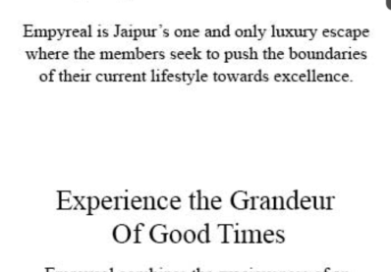 remove the blank space…..lots of blank space - **Done**
8. Add the homepage15 secs walkthrough video - **Done**
9. IAC logo also should be there - - **Done**
10.  T& c, limited period offer above the phone no - **Done**
11. Share the desktop & mobile version both
12. 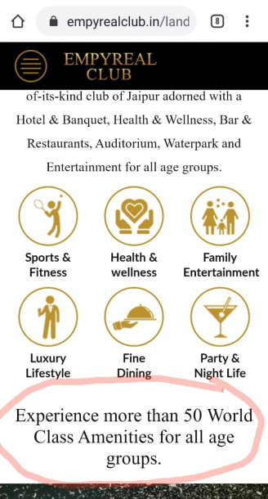 This heading will come above the icons for the landing page **- Done**
13. 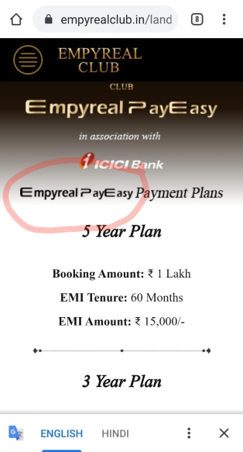 Empyreal pay easy will be in golden colour only – **Need discussion**
    1. 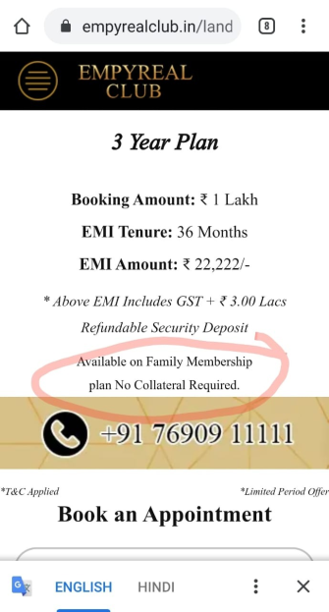 Plan will come in the top line.....there has to be a full stop after Plan - **Done**
14. Add the section of Empyreal Times into the Media section - **Added** - https://www.empyrealclub.in/empyreal-times/  
    on the Homepage......why still not activated? – Not getting this -